SAP HR ( Human Resources ) is one of the largest functional module in SAP.Its called SAP HR or SAP HRMS, HCM or SAP Human Resources. It contains the main sub modules Organizational Management,Personnel Administration,Recruitment,Time Management , Payroll,Compensation Management,Personnel Cost Planning , Budget Management,Personnel Development , Training & Event Management , Travel Management , Environmental Health & Safety.In this page you will get some SAP HR Tutorials and PDF training guides to download.

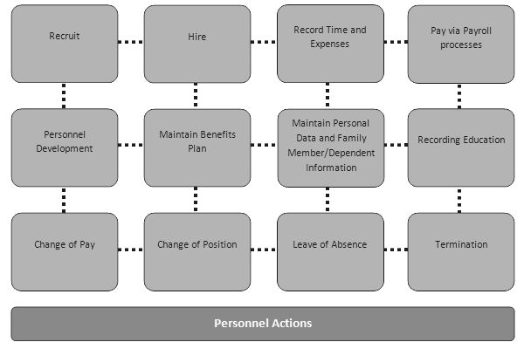

#### Class Summary

SAP Human Capital Management (HCM) is also called SAP-HR. SAP HCM consists of important sub-modules like Personnel Administration (PA), Organizational Management (OM), Time, Payroll all of which will be discussed in detail.

#### What should i know?

Familiarity with SAP GUI is a plus. If you are an absolute beginner to SAP please take this basic SAP course first.

### Syllabus

**All About Infotypes!**

1 — What is an Infotype?

2 — How to Create an Infotype

3 — How to DISPLAY an Infotype

4 — How to CHANGE an Infotype

5 — How to COPY an Infotype

6 — How to DELETE an Infotype

7 — How to display OVERVIEW an Infotype

8 — Fast Entry

**Some More Infotype Information**

9 — How to view all Infotypes Saved for an Employee

10 — All About Infotype 0003 – Payroll Status

11 — Time Constraints

**Important Personnel Administration Topics**

12 — SAP Personnel Actions

13 — How to Delete a Personnel Number

## Organizational Management

**First Steps**

14 — Structures In SAP

15 — Object Types , Validity Dates , Infotypes

16 — Relationships

17 — Expert Mode

18 — Simple Mode

**Organizational Units**

19 — How to Create an Organizational Unit

20 — How to Create an Organizational Unit within existing Structure

**Positions**

21 — How to CREATE a Position

22 — How to COPY a Position

23 — How to DELIMIT a Position

24 — Identify a Position as Head of Org Unit

25 — How to assign a Job & Cost Center to a Position

## Time

**About Time we discuss TIME!**

26 — Time Evaluation Essentials

27 — How To Run Time Evaluation

28 — How To CHECK Time Evaluation Results

## Payroll

**Important Concepts**

29 — Overview Of Payroll Process

30 — What Is Payroll Area and Period

31 — Control Record

32 — How to execute Payroll

33 — How To Check Payroll Results

34 — How to DELETE Payroll Results

**Must know Payroll Information**

35 — How to Execute Payroll in Background

36 — What is Off Cycle Payroll

37 — How to Audit Payroll

38 — What is MATCHCODE W

39 — Types of WageTypes in SAP

40 –Wage Type Reporter

**Post Payroll-Run Activities**

41 — Bank Transfer

42 — How to Create a Bank Key

43 — Posting to General Ledger

44 — All About Ad-Hoc Query